**Project 15: Working with Lambda**

Step1: Create two s3 buckets with the name

source bucket : arn:aws:s3:::sourcebucketd15

destination bucket : arn:aws:s3:::destinationbucketd15

ss1:

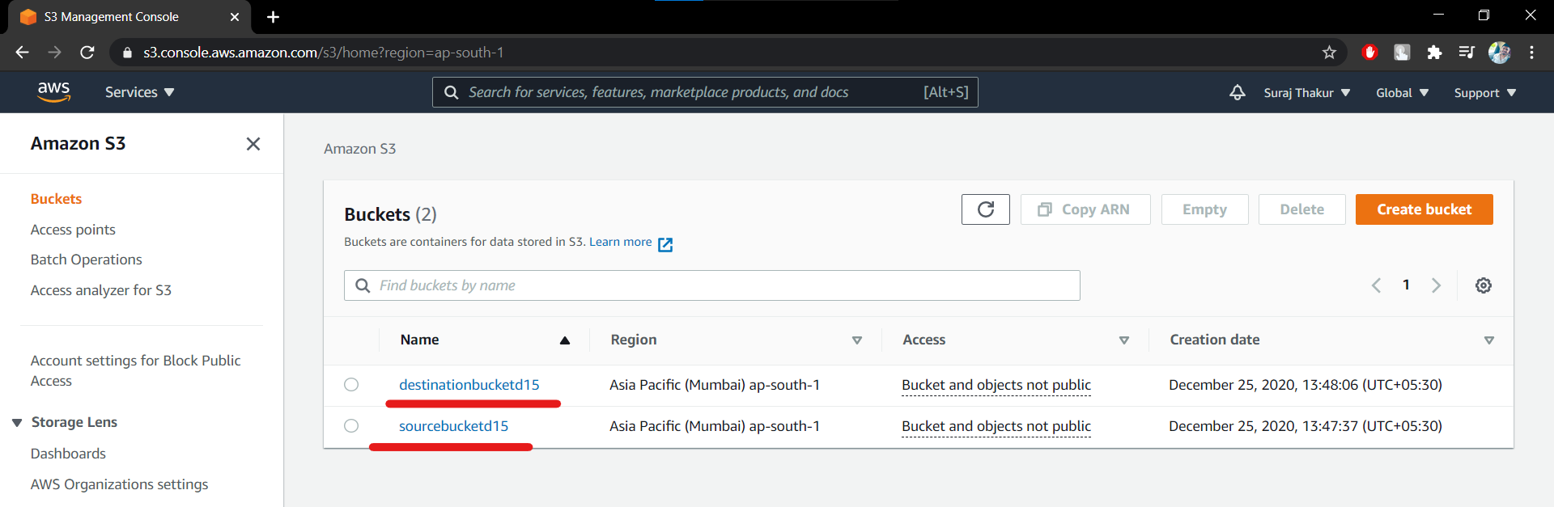

Step2: Create a policy with limited Read-write permissions using a JSON script

ss2:

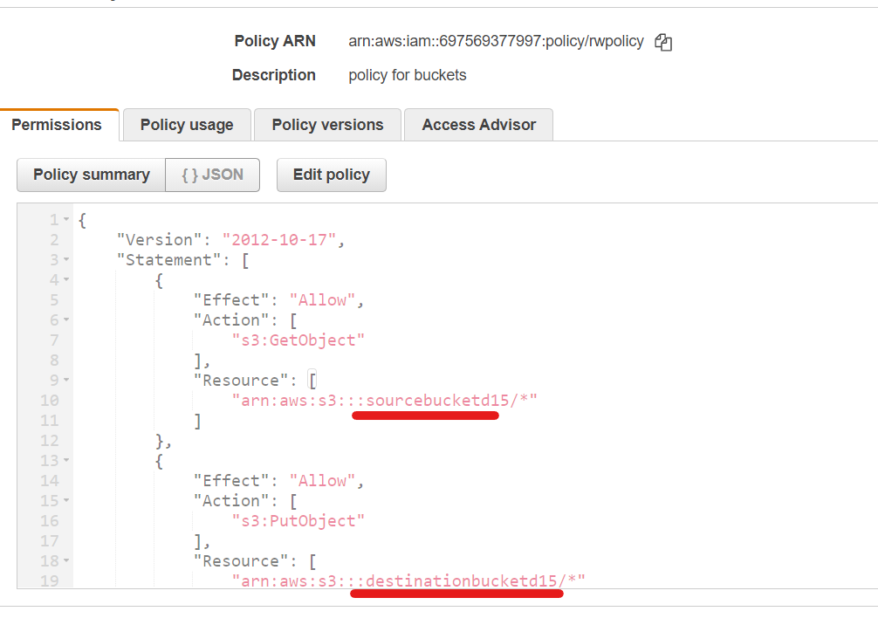

ss3:

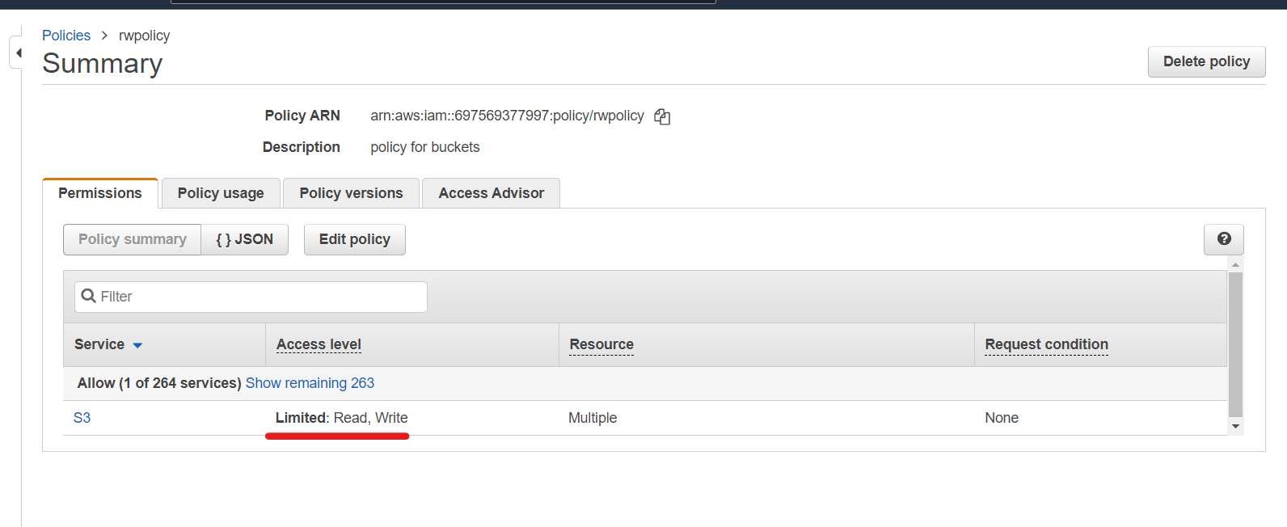

Step3: Create a role and attach the policy that was created in the previous step.

ss4:

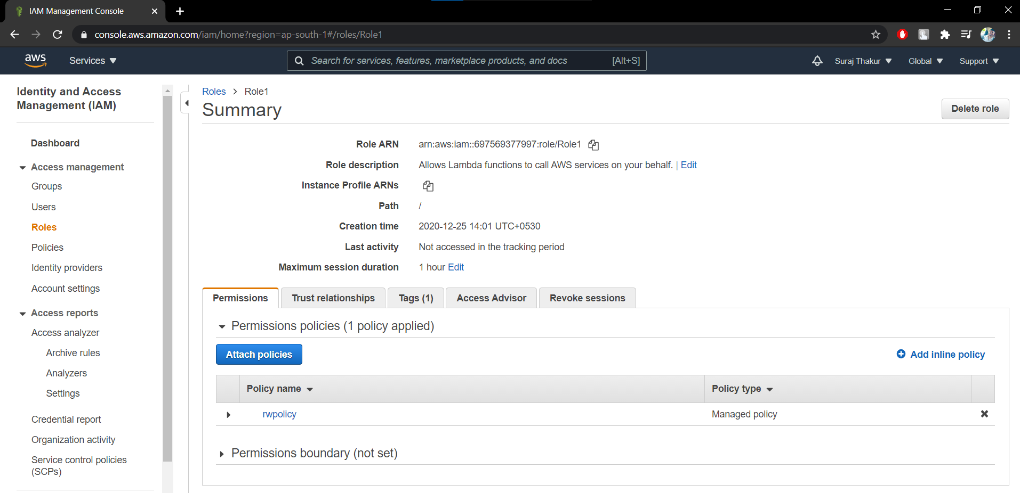

Step4: Create a Lambda function

ss5: Lambda functions dashboard

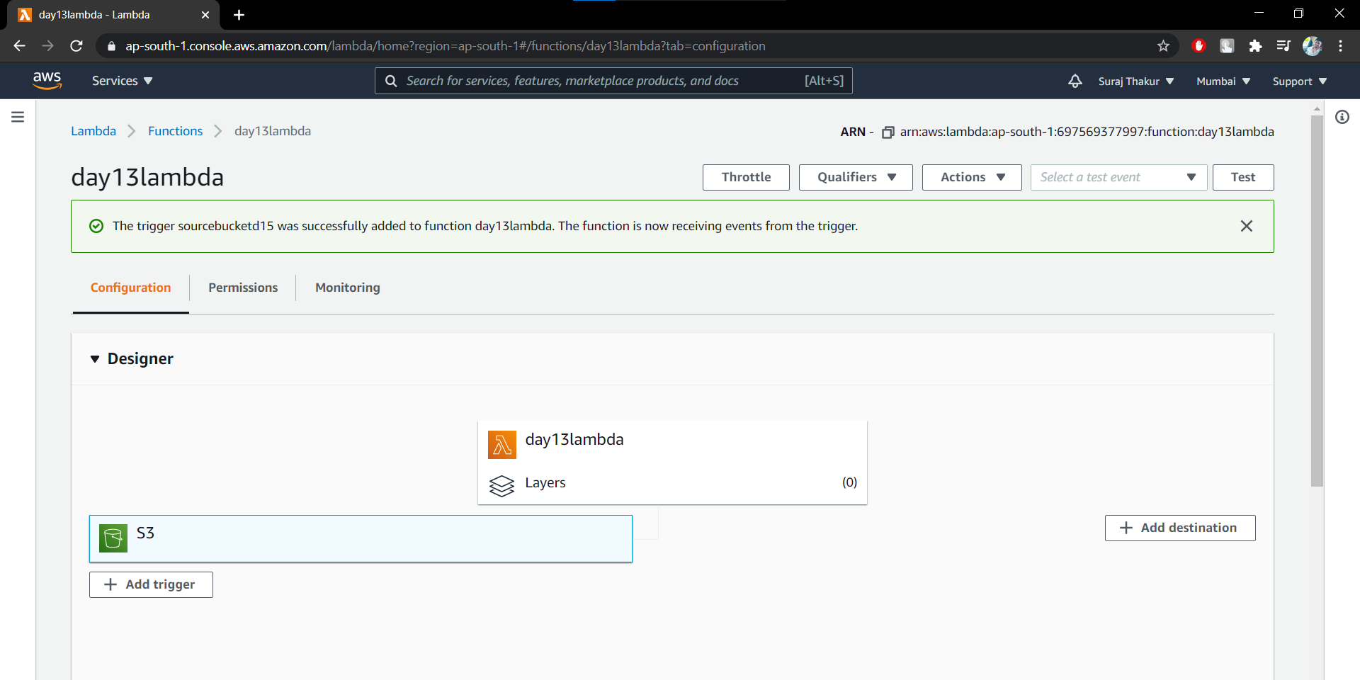

ss6: Write js file in the lambda function by editing the previous code

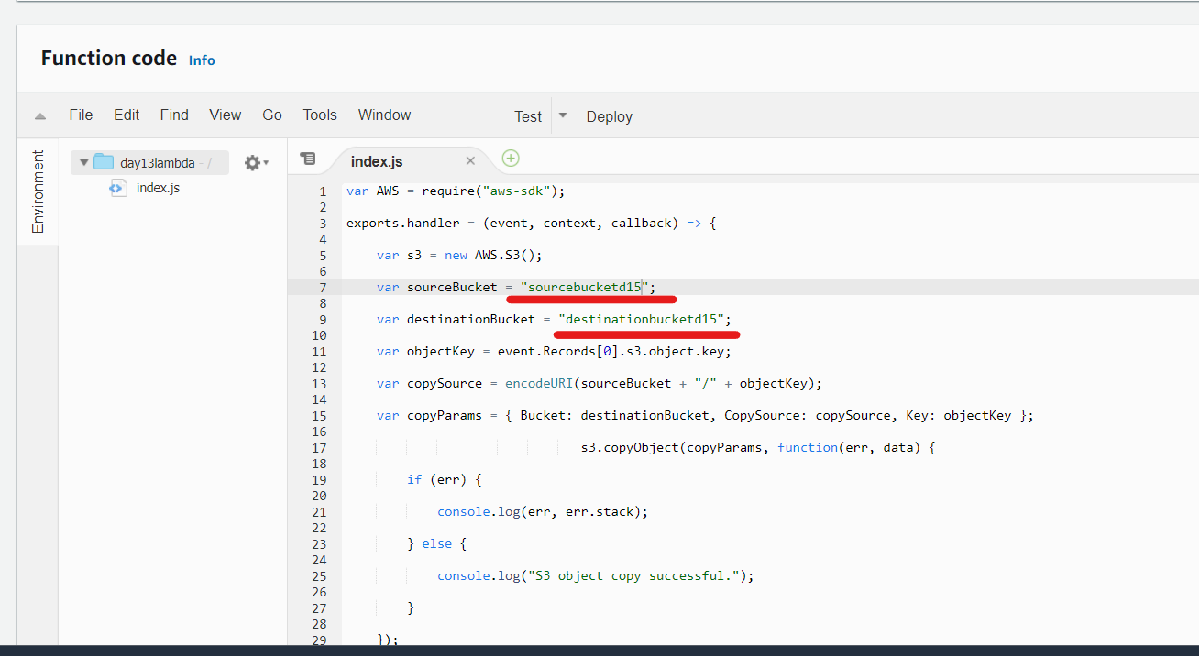

Step5: Adding triggers to the lambda function

Step6: Test by uploading objects into the source bucket

ss7: Upload an object file in the source bucket

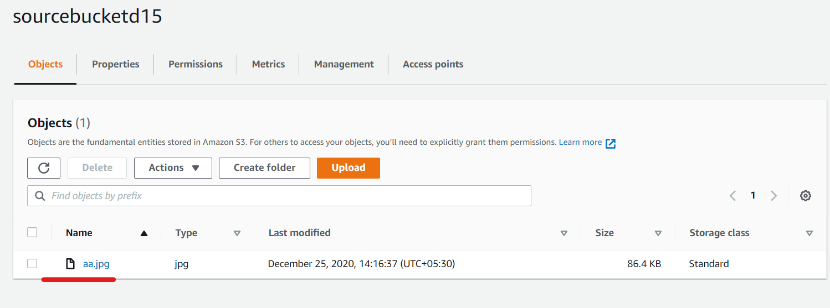

ss8: Confirm that the object from the source bucket is replicated in the destination bucket

